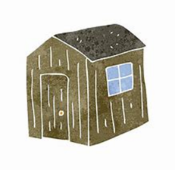
Uckfield Shed Code of Conduct
The Code of Conduct will be strictly enforced for every person in Uckfield Shed (the Shed) at any time.

- No form of abuse, neglect, violence, anti-social behaviour or of the rights of others will be tolerated.

- Alcohol and drugs are prohibited in the Shed and any person entering the Shed showing signs of having taken alcohol or drugs will be asked to leave immediately.

- Members of the Shed will respect the confidentiality of all individuals, whether present or not, and refrain from mentioning specific information which may cause embarrassment of any member, unless given their consent.

- Members must accept that the Shed exists for the benefit of all of its members, irrespective of religion, political views, nationality, disability, age or race.

- Members of the Shed shall treat each other with fairness and consideration, showing regard for people’s feelings and respect for their contribution.

- Sheds work best when members work as a team. Every member should take responsibility for helping and supporting each other.

- Every member has a responsibility for Health and Safety and ensuring procedures are adhered to at all times by all members. Every member should see themselves as a safety officer, regardless of any formally appointed positions for that purpose.

- Differences can sometimes get personal or be hard to resolve for other reasons. Members should be prepared to recognise when this is happening. They should be ready to find fair ways of cooling things down through mediation or team building sessions, for the benefit of everybody. If no resolution can be found, the Management Committee will decide how to resolve the issue in accordance with their voting procedures set out in the constitution.

- No member of the Management Committee shall use their position of power for personal gain or wrongful treatment of others.

Any person breaching the Code of Conduct will be asked to leave the Shed and the Management Committee will make a decision as to whether the person will be permitted to return to the Shed.

